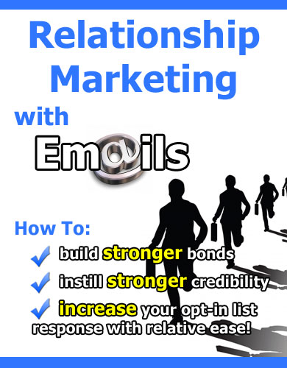

Relationship Marketing With E-Mails

“How To Build Stronger Bonds, Instill Stronger Credibility And Increase Your Opt-In List Response With Relative Ease!”

LEGAL NOTICE

The Publisher has strived to be as accurate and complete as possible in the creation of this report, notwithstanding the fact that he does not warrant or represent at any time that the contents within are accurate due to the rapidly changing nature of the Internet.

While all attempts have been made to verify information provided in this publication, the Publisher assumes no responsibility for errors, omissions, or contrary interpretation of the subject matter herein. Any perceived slights of specific persons, peoples, or organizations are unintentional.

In practical advice books, like anything else in life, there are no guarantees of income made. Readers are cautioned to reply on their own judgment about their individual circumstances to act accordingly.

This book is not intended for use as a source of legal, business, accounting or financial advice. All readers are advised to seek services of competent professionals in legal, business, accounting, and finance field.

You are encouraged to print this book for easy reading.

TABLE OF CONTENTS

Chapter 1: Introduction 7
You’ve Got Mail! 7

Chapter 2: Building Relationships 9
Developing The Competitive Edge 9
Tips On Building Rapport With Your Subscriber 10

Chapter 3: Instill Stronger Credibility 12
Establish Yourself As An Authority 12
Use E-courses To Build Credibility Over Time 13

Chapter 4: Increase Your Opt-in rates 14
Crafting An Excellent Squeeze Page 14
Install Viral Friend Generator 15

Chapter 5: Common Mistakes People Make 18
What You Must Avoid At All Costs 18

Chapter 6: Summary 20
The Speed Of Trust 20

Recommended Resources 21

Relationship Marketing
with E-mails

“How to build stronger bonds, instill stronger credibility and increase your opt-in list response with relative ease!”

Chapter 1: Introduction

You’ve Got Mail!



Welcome to “Relationship Marketing With E-mails”!

In this book you learn all about one of the best ways to build your Internet marketing business – which is through E-mail marketing.

But before we dive in, let’s take a look why E-mail marketing is so effective in the Internet marketing industry.

- E-mail marketing is one of the fastest ways to leverage on the Internet. Because all you do is compose an E-mail, customize it to suit the reader (their first name or last name), and click the broadcast button to reach thousands of people instantly!

- E-mail marketing is highly scalable. Unlike an ‘offline’ business where the more customers you have, the busier you are, in E-mail marketing, it is much easier because regardless of the size of your mailing list, whether it is 100 or 10,000, all you need to do is click broadcast and everyone on the list gets notified – all for the same effort!

- E-mail marketing is highly targeted. One of the reasons why E-mail marketing is highly effective at getting sales is because the recipient of the E-mail gets a kind of ‘in your face’ promotion. You are marketing directly to the customer through their PERSONAL mailbox. Not only will you grab their attention firmly, they will tend to respond with the right buyers mindset because they are marketed to directly (unlike other advertising where the buyer might not be in the frame of mind to buy things).

- E-mail marketing is personal. Autoresponders allow you to customize the E-mail in such a way that it allows you to connect with the subscriber individually. The more personalized your E-mail, the better the result (treat it as though you are writing to your best friend).

- You can automate many tasks with your autoresponder. For every new opt-in subscriber, you can time your E-mails for you build a relationship with every new opt-in subscriber – what to send to them, when to send it to them and the frequency between each E-mail.

- E-mail marketing acts as a good pre-sell. You might not be able to cram a sales letter into your E-mail, but at least you can pre-sell your subscriber and lead them to your blog, sales letter or website to check out what you have to offer and set them in the right frame of mind before they evaluate what you have to offer.

In the next few chapters, you will learn the techniques on how to build stronger bonds, instill stronger credibility and increase your opt-in list response with relative ease… all with E-mail marketing!

Chapter 2: Building Relationships

Developing The Competitive Edge



One of the most important things you must do to achieve success online is to build a solid relationship with your subscriber.

Building a relationship is important because it can make the difference between making a sale and losing it to your competitor.

You see, just like in real life, if I had to choose between a friend who provides a service like car repair and a stranger who offered the same price, I choose my friend in less than a heartbeat.

Why? Because I’d rather give HIM my business compared to another stranger.

E-mail marketing can be quite competitive at times. Therefore when two marketers are promoting the same product, having a strong rapport with your subscribers will give you a competitive edge.

Take for example:

During a massive launch online where high ticket items are being sold and tons of marketers everywhere are sending E-mails to their subscribers, most marketers would be offering bonuses to ‘bribe’ their customers to buy through their affiliate link.

Sometimes, 3 or more would be pitching the same offer with similar value. So the question you should be asking yourself is if you were in the shoes of your subscriber, why should your subscriber buy from YOU instead of other marketers?

Once again, if you have built a strong relationship with your subscriber, they will be on your side – especially if you are trying to win an affiliate contest.

Tips On Building Rapport With Your Subscriber

One of the best ways to build relationships with your subscriber is to strengthen the rapport between you and your customer.

Here are a few ways to achieve that:

- Keep in touch with your mailing list often. Don’t mail them only when you need to promote a product.

- Ask about their needs and concerns. Use questionnaires and get them involved. Ask them what they want you to provide for them to help them with their Internet marketing business.

- Send them gifts sometimes. It could be in the form of free reports, blog templates, graphics or even free membership access!

- Be personal. Let them see your human side or your personal life. It sure beats dry, stale E-mails that talk about product launches all day.

- Be educational. When you impart something of value to your subscribers, they will see you as a teacher and listen to what you say. This will come in handy when you want them to ‘listen’ to you and buy whatever you are selling.

Chapter 3: Instill Stronger Credibility

Establish Yourself As An Authority



When you take a look at the average Joe on the street, you may think that there is nothing special about them – until they step up on a podium and start talking about a subject with an air of authority surrounding them.

If you want to succeed at Internet marketing, you must be able to instill stronger credibility to your subscribers by establishing yourself as an authority on your niche market.

For example: when you are talking about making money through product launches, you must let your subscribers know about your credibility either before or after they opt-in to your mailing list.

Here are a few tips on establishing your credibility:

- Talk about your experiences online and offline. If you’ve run an offline business before, use it to establish your credibility as a business builder. If you’ve been in sales and marketing before, use it to establish your credibility as a copywriter.

- Show them screen shots of how much money you’ve made online (or checks you’ve earned). If you don’t have any of these, use photos of well-known marketers you’ve taken pictures with (e.g. look, here is my picture taken with Mike Filsaime)

- Let others tell the story. It would be better to let others sing your praises – especially in the form of testimonials.

Use E-courses To Build Credibility Over Time

People may not be impressed at the first glance. Sometimes, it takes a few E-mails for people to recognize your capabilities.

One of the ways you can build your credibility over time is to write an E-course or a newsletter that will be sent to your subscriber’s E-mail over a period of days or weeks. It must be something educational – something that will establish you as an expert on the subject.

You can configure your autoresponder to send an E-course once everyday, every two days or a weekly newsletter. So long as the subscriber reads your educational material over a period of time, you can slowly work your way into the heart of your subscriber and stamp a firm impression in their minds.

Chapter 4: Increase Your Opt-in rates

Crafting An Excellent Squeeze Page
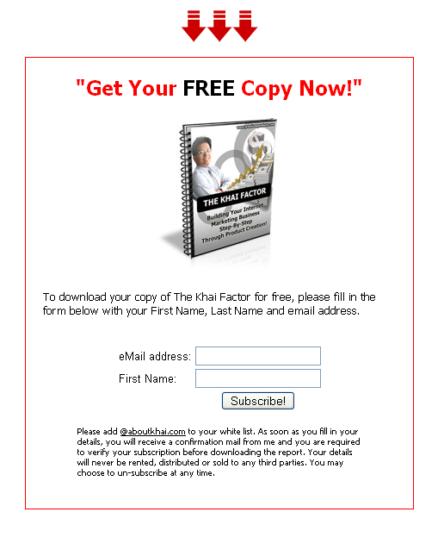

This is an example of a squeeze page that will get opt-in subscribers to join your mailing list.

If you want to increase your opt-in rates, here are a few principles you must apply to your squeeze page:

- Use compelling arrows to inspire visitors to take action. Believe me, graphics and aesthetics make all the difference!

- Craft a compelling E-cover for the special report or E-book you are giving away. If you are giving away an audio Interview, you can show a picture that displays an audio CD or DVD to increase the perceived value of the product people are downloading in exchange for their E-mail address.

- Use a powerful headline to grab people’s attention.

- Use checkboxes to inspire people to get involved with the benefits of your free product.

- Remember to add a disclaimer below the opt-in box to assure people that they are not getting spammed or that their E-mail address will not be used for unscrupulous purposes.

Install Viral Friend Generator

Viral friend generator by Mike Filsaime is an excellent script that you can use to dramatically increase your opt-in rates.

What it does is that it lets subscribers generate subscribers FOR YOU.

Here is an example of how it works:

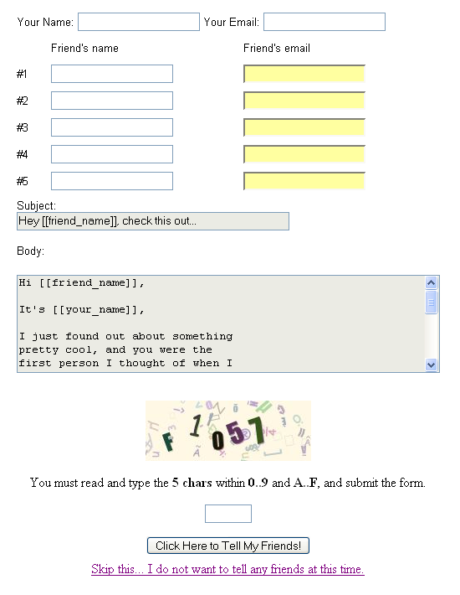

You key in your name and E-mail address. Later on, you type in at least 3 friends’ name and E-mail addresses in exchange for a free gift.

This is a “tell-a-friend” script. The friends will receive an E-mail that is sent directly from the referring subscriber to their friends on a one-on-one basis.

There is also a security check box at the bottom where you have to enter a few letters or numbers to fight spam and ensure that the people referring the friends are HUMANS (after all, computers can’t read graphical images).

Imagine if one opt-in subscriber refers at least 3 friends, and these 3 friends each refer 3, and so on.

If you get at least 2 subscribers a day and each of those 2 bring in another 2, imagine how many subscribers you will get after 30 days?

I’ll let you do the math! ☺

Chapter 5: Common Mistakes
People Make

What You Must Avoid At All Costs



If you want to build a solid relationship through E-mails, you must be very careful NOT to commit these E-mail marketing ‘sins’:

- Spamming! Never, ever ‘spam’ your mailing list. Even though they have given you permission to E-mail them, that doesn’t mean that you can send them E-mails and sales pitches on a daily basis. Learn to send E-mails at strategic intervals.

- Mailing them only when you are selling something. No one wants to be on your list if all you ever do is sell, sell, sell! The reason people join your mailing list is because they want something of value for being on your list. If they fail to see your value, they will unsubscribe even faster than you can say, “opt-out”!

- Rushing your Emails. When you are doing a promotion, one of the biggest mistakes you can make is that you rush your E-mails to the point that the mistakes are spotted by most of your subscribers. Having too many mistakes in your E-mail will make you look unprofessional. It is quite embarrassing when you spell a person’s name wrongly (the word {first_name} appears instead of the subscriber’s real name) or worse… screwing up your affiliate links!

- Not mailing your list for a long time. The opposite of spamming. If you don’t keep in touch with your subscribers for a long time, they will tend to forget who you are. And that will severely damage the relationship between you and your subscriber.

- Not relating to your subscribers. When every new product launches, there is a tendency to mail your subscribers all the time while forgetting that the product doesn’t relate to the subscribers at all. You don’t want to sell cat food to people who don’t own a pet!

Chapter 6: Summary

The Speed Of Trust



In a nutshell, building relationships through E-mail marketing is all about trust. The more a person trusts you, the easier it is go get them to do what you want them to do.

It may take a long time to build trust but remember that trust can be shattered overnight.

Always put yourself in the shoes of your subscriber and give them as much value as possible and you can be sure E-mail your way to victory!

To your success!

BONUS! Grab Your Lifetime GOLD Membership Access To:
PLRSECRETSEXPOSED.COM
($97.00 Value)

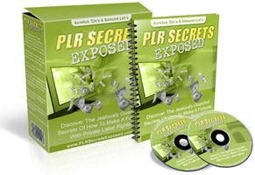

Discover the jealously guarded secrets of Top Internet Marketers who are making a killing from Private Label Rights! Imagine learning things like:

- The expert answers to the most Frequently Asked Questions on Private Label Rights!

- How to take full advantage of every Private Label products you have in your hard drive and convert them into cash!

- How to effortlessly create your very own Private Label content at ZERO cost!

- What to look out for in a Private Label product before purchasing it,

- How to smack your competitors flat even though they may own the Private Label Rights and (Master) Resell Rights to the same products as you do!

- And so much more! This is barely in a nutshell.

Click Here to Join PLRSecretsExposed.com as a Gold Member FREE!

BONUS! Grab Your Lifetime GOLD Membership Access To:
RESELLRIGHTSMASTERY.COM
($197.00 Value)

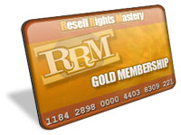

Gain INSTANT access to Resell Rights Mastery as a Gold member and get your hands on:

- A constantly adding collection of brand new Resell Rights products that you can resell and keep all the sales,

- Rich Private Label Article archive that you can use to build your own Information Products and expand your Online Empire,

- Beautiful templates that you can for your own graphic design purposes – E-covers, web pages, etc.

- Advanced Reseller Strategies NOT covered in most paid products on the same subject,

- And much, much more!

Click Here to Join ResellRightsMastery.com
as a Gold Member FREE!

